**Intelligent Access Control System For Safety Critical Areas**

***Introduction***

In some industries it is necessary for the workers to wear safety helmets and shoes while working. So to check weather workers are taking safety precautions or not we are proposing this system.

We can train our classifier to identify helmet and safety shoes with IBM Cloud. There will be video streaming near the entry of the industries where we can first detect the face of a person and if any person is present then we can capture the image of that moment and send it to IBM Cloud to detect whether the person is wearing helmet or shoe.

If the person is wearing shoe and helmet we can give him access by opening the door. If he is not wearing then we can restrict his access by not opening the door. We can even warn him through voice commands to take the safety precautions

***Literature Survey***

In some industries because of the violating the safety precautions . Industries are have been facing many accidents .which are leading to the loss of properties and lives of the people. so to overcome that issue , intelligent access control system for safety critical areas system could help .By allowing the person with proper safety equipment.

***Theoretical Analysis***

HARDWARE AND SOFTWARE DESIGN :-

        SOFTWARE :

* Install Python IDLE
* Download wiotp.sdk.device library
* Create IBM Account
* Create Node-Red Application
* And Create Node flow
* Create IBM Watson IOT Platform
* Create Text to speech service
* Create Cloudant DB
* Create a cloud object storage service

Block Diagram :

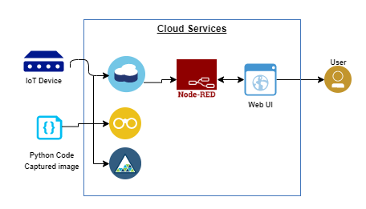

***Experimental Investigations :***

* After creating all the services ,run the program.
* Then its start detecting the person,and takes the data and upload to Cloudant DB.
* It also stores the data(images) in the cloud object storage.
* Where the user can access those url and the images.
* We have created the node flow and the user inter face.
* With the help of text to speech voice commands are generated.
* After the output the user can visual the data.

***RESULT :***

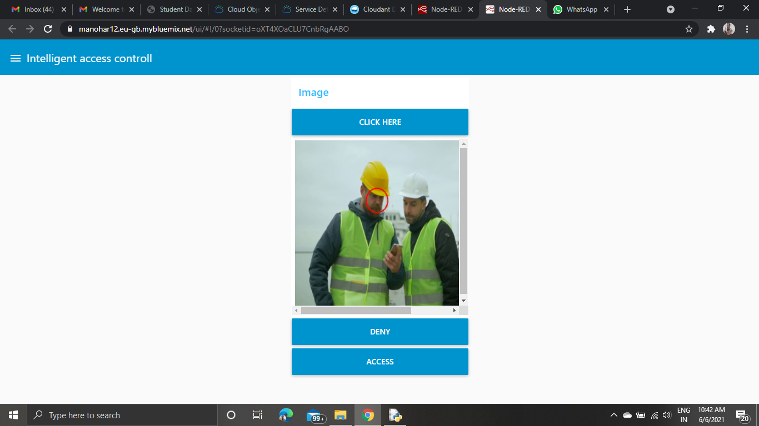

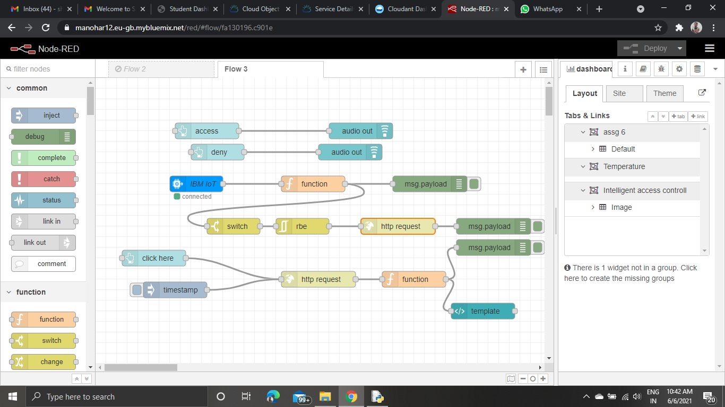

***Advantages and Disadvantages :-***

Advantages :

INCREASE EASE OF ACCESS FOR EMPLOYEES

An access control system allows you to “set and forget” who has access to each area of your business. Once you give the authorization, an employee can access all the areas they need to get their jobs done. With the scan of a key card or input of a PIN, the employee can get to wherever they need with ease.

**GET RID OF TRADITIONAL KEYS**

The use of traditional keys has a few drawbacks. Restricting access to particular areas requires individual keys. The larger the building, the more locks you need. For an individual like a janitor or a high-clearance individual, this can mean a bulky key ring and confusion about which keys do what. An access control system saves time for those accessing restricted areas and also saves you visits from the locksmith.

Also, keys can be duplicated, leaving you vulnerable to unauthorized access. If an employee doesn’t turn in their key before they leave your company, you leave yourself unprotected or must get your locks changed. Access control security does away with this.

**SAVE MONEY AND ENERGY**

With access control security, you save money on locks and security personnel. An access control system can verify a person’s identity without the need for a security guard.

Access control systems can also be integrated with lighting, heating and cooling systems. Lights can turn on when there are people in a room and will shut off when they leave. You can also adjust temperatures when no one is in an area to save on energy costs.

**KEEP TRACK OF WHO COMES AND GOES**

An access control system gives you data on who enters and exits a building or room and when. You can ensure people are working when they are supposed to be. If theft or an accident occurs, you know exactly who accessed a specific area at the time of the incident.

**PROTECT AGAINST UNWANTED VISITORS**

A large company creates an opportunity for visitors to go undetected. One of the benefits of using access control systems is that unauthorized people cannot get in. Since doors need credentials before they unlock, only those you’ve given credentials to can access the area. With this system, you can be sure everyone in your building is supposed to be there, whether you know them or not.

**COMPLY WITH INDUSTRY REGULATIONS OR SECURITY STANDARDS**

There are many regulations for data security that need restrictions on physical access to data. Anyone in the healthcare industry must comply with HIPPA, but most organizations are subject to these regulations as well. If an employee or student requests a medical leave, records of the individual’s illness must be kept secure. In the world of commerce, customers’ financial information must be kept safe, and IT Departments must restrict access to servers and digital data.

All this information, whether it is a digital or paper file, can be secured with an access control system.

**REDUCE THEFT AND ACCIDENTS**

You can protect your company’s assets, expensive equipment or even office supplies by controlling access. You can restrict access to supply closets and computer banks, so only trusted individuals can access them. Employees know their arrivals and departures are tracked, which deters theft.

Also, lab equipment or chemicals in schools or hospitals can injure people who aren’t trained to use them. To prevent accidents, you can restrict access to only those who know how to follow safety protocols.

PREVENT AGAINST DATA BREACHES

Health information, financial records and client data are often stored on company-owned servers. Access control systems can restrict or grant access to IT rooms and even individual computers or networks, so only trusted individuals may access them.

Disadvantage:

Hacking

Access control systems can be hacked. When a system is hacked, a person has access to several people's information, depending on where the information is stored. [Wired](http://www.wired.com/2007/08/open-sesame-acc/) reported how one hacker created a chip that allowed access into secure buildings, for example. Not only does hacking an access control system make it possible for the hacker to take information from one source, but the hacker can also use that information to get through other control systems legitimately without being caught. Despite access control systems increasing in security, there are still instances where they can be tampered with and broken into.

***Applications :***

Can be used in special areas like Airports, Port Trusts, Naval Base, Military base, Telecom buildings, Refinery, Petroleum handling areas etc. needed highly sophisticated security and access control system.

***Conclusion :***

We have came up with an  access system ,which provide a high level of security for the user.

***Bibliography***  ***:***

* Smart Internz mentors
* Smart Internz lecture videos
* Smart Internz material

***Appendix :***

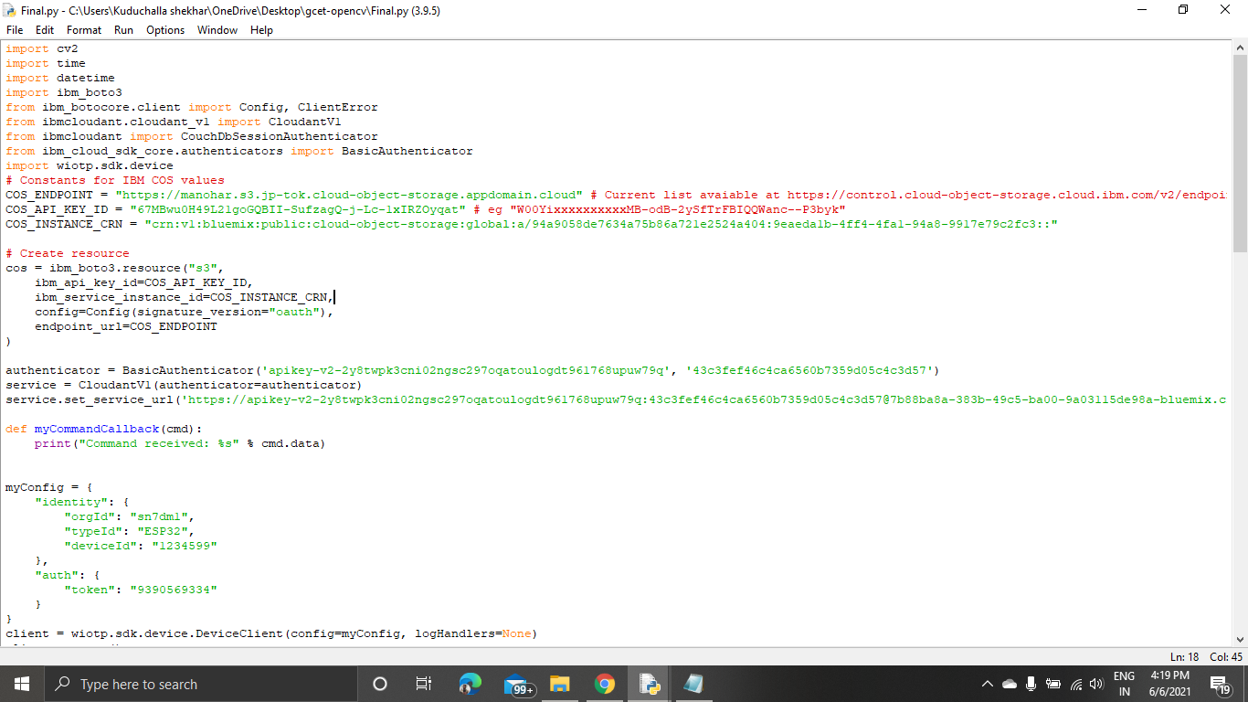

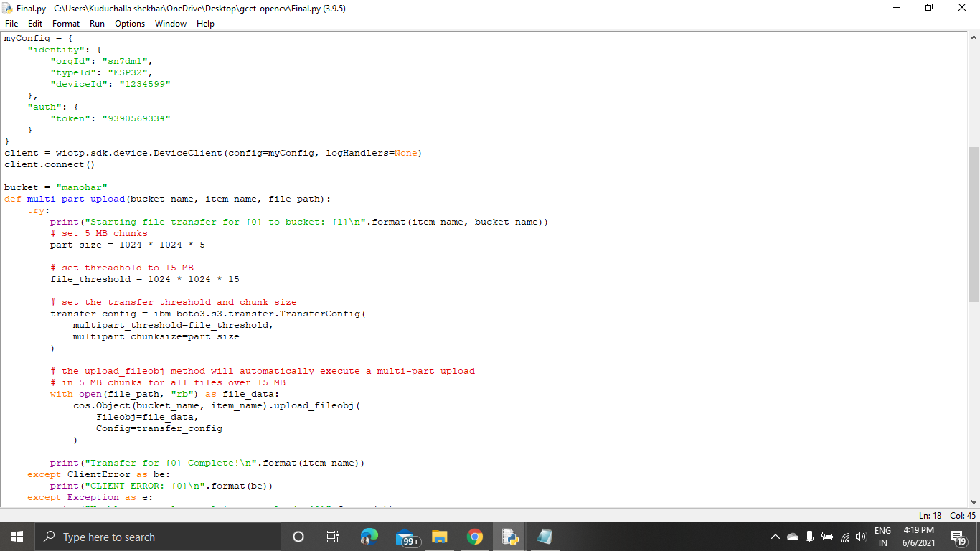



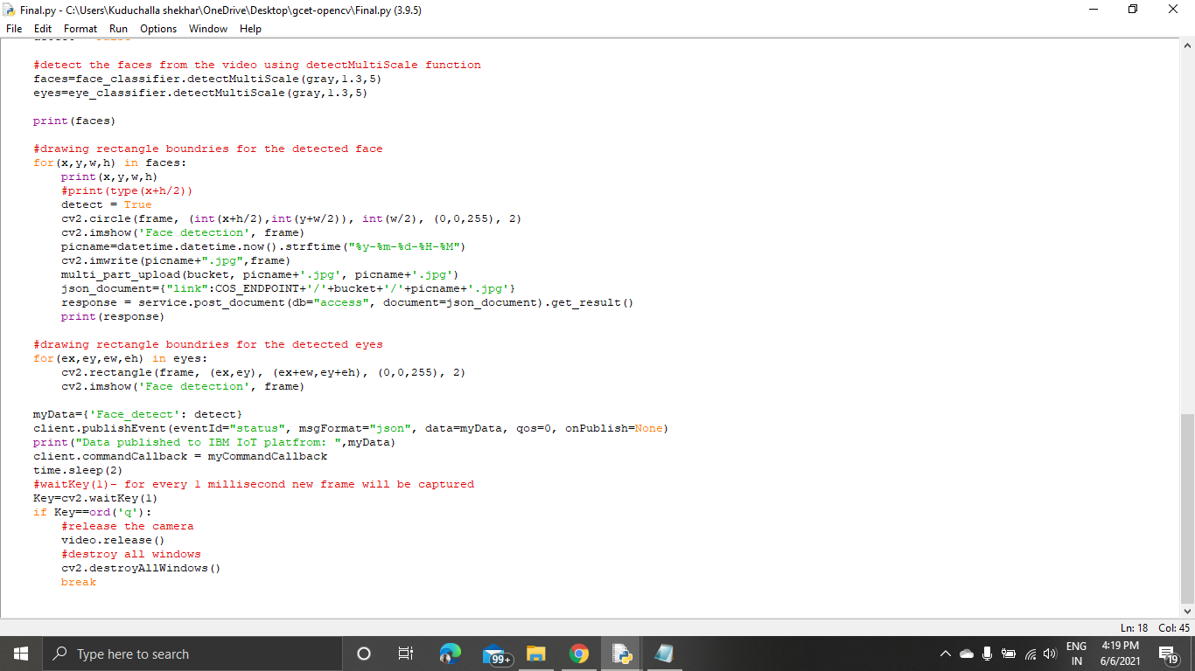



**THANK YOU**

**M.SATHWIK SAI -19R11A04C3**

**M.S.V SAMPATH -19R11A04C4**

**M.SAI SARATH CHANDRA-19R11A04C1**

**K.MANOHAR-19R11A04B9**

**KALVA LAHARI-19R11A04B6**